**Aligning Local English Assessment Practices with the CEFR: A Case Study of Vietnamese Regional Universities**

**Luong Manh Ha**

Lecturer of Tan Trao University, TuyenQuang Province, Hanoi, VietNam Address: Km6 National Highway 2C, Trung Mon Commune, Yen Son District, Tuyen Quang Province. Telephone: +84 0846979588 Email: [lmha.dhtt2024@gmail.com](mailto:lmha.dhtt2024@gmail.com)

***Abstract***: Amid Vietnam’s national push toward educational standardization, the Common European Framework of Reference for Languages (CEFR) has been widely promoted as a foundation for English language assessment. While prior studies have focused on CEFR adoption at national and urban levels, little is known about how regional universities interpret and operationalize CEFR-based assessment in their localized contexts. This study investigates current practices, perceptions, and challenges surrounding CEFR-aligned English testing at three Vietnamese regional universities. Using a mixed-method approach—including surveys with 250 students, interviews with 15 lecturers and 6 academic administrators, and content analysis of six institutional English tests—the study reveals significant gaps between intended CEFR alignment and actual assessment design. Findings highlight the lack of teacher training, inconsistent institutional guidance, and limited availability of CEFR-informed test models. The paper contributes original insights by examining internal test development and offering locally responsive recommendations for integrating CEFR into assessment frameworks at under-resourced institutions.

***Keywords:*** CEFR-based assessment; language proficiency; Regional Vietnamese universities; Competency-based evaluation; Language testing practices

**1. Introduction**

In recent years, Vietnam’s higher education system has undergone significant reforms aimed at improving educational quality, graduate employability, and international compatibility. Among these efforts, the adoption of the Common European Framework of Reference for Languages (CEFR) has become a central policy tool for standardizing English language education and assessment across all university levels (Ministry of Education and Training [MoET], 2023). The CEFR provides a comprehensive framework for defining and evaluating language proficiency in terms of communicative competence and task-based performance, making it highly relevant for outcome-based education (Council of Europe, 2020).

While CEFR has been embraced in national language policy and urban universities, its localized implementation in regional and under-resourced institutions remains underexplored. Existing literature predominantly focuses on national standardization efforts, high-stakes testing (Nguyen & Nguyen, 2021), teacher training initiatives (Pham & Phan, 2022), or curriculum alignment at metropolitan universities (Le, 2020; Tran, 2019). However, few studies have examined how CEFR-aligned assessment is interpreted, adapted, and executed in provincial universities where resources, policy awareness, and assessment capacity are often limited (Dang, 2020; British Council, 2021). As a result, there exists a significant gap between national assessment policy and actual classroom practice in these localized contexts.

This study seeks to address that gap by investigating CEFR-based English assessment practices at three regional Vietnamese universities. It aims to: (1) explore how institutional English language tests align with CEFR descriptors; (2) examine the perceptions of lecturers, students, and administrators regarding CEFR-based assessment; and (3) identify challenges and opportunities for implementing CEFR in local settings. Through this focus, the paper provides empirical evidence and critical reflections that may inform future policy refinement and localized test development strategies in Vietnamese higher education.

**2. Literature Review**

*2.1. CEFR and Its Global Relevance.* The Common European Framework of Reference for Languages (CEFR), developed by the Council of Europe, offers a comprehensive framework for assessing language proficiency across six levels (A1–C2), with descriptors linked to communicative competence and real-world task performance (Council of Europe, 2020). Over the past two decades, CEFR has gained global recognition as a reliable benchmark for language teaching, curriculum design, and assessment, particularly in contexts seeking to enhance international compatibility in higher education (Little, 2011; North & Piccardo, 2016).

The benefits of CEFR-based assessment include transparency of language expectations, improved validity of testing instruments, learner-centered progression, and the ability to link national standards to an internationally recognized scale (Alderson, 2007; Figueras, 2012). Many countries in Asia, including Japan, China, and Vietnam, have formally adopted CEFR in national education reforms to standardize and globalize English language outcomes (O’Dwyer et al., 2017).

*2.2. CEFR Implementation in Vietnam.* Vietnam has made a formal commitment to CEFR through the adaptation of CEFR-V, a localized version used as a reference in national policies for foreign language education (MoET, 2019). According to the National Foreign Language Project 2020 and subsequent directives, university graduates are expected to attain levels ranging from A2 to B2 depending on their major (Pham & Phan, 2022). However, the transition from traditional grammar-translation methods to CEFR-aligned assessment has revealed considerable implementation challenges.

Several studies have investigated how CEFR has been introduced in Vietnam. For instance, Dang (2020) explored teacher readiness and found gaps in assessment literacy and understanding of CEFR descriptors. Nguyen and Nguyen (2021) reported inconsistencies between test content and CEFR benchmarks in many institutions. Others, like Tran (2019) and Le (2020), identified the mismatch between centralized policy objectives and institutional autonomy in assessment design. Despite widespread policy support, implementation remains uneven across institutions, especially at regional universities.

*2.3. Gaps in Existing Research.* Although CEFR-related studies in Vietnam have expanded, most are policy- or teacher-focused, with limited empirical work on localized assessment tools. There is a critical lack of comparative studies that explore **internal English testing practices** across regional universities. Moreover, few researchers have examined how internal tests align with CEFR descriptors, or how students and academic staff perceive this alignment in under-resourced contexts.

The following two tables summarize the **scope, focus, and limitations** of the ten key studies reviewed, revealing the empirical and contextual gaps this paper aims to address.

|  |  |  |  |  |  |
| --- | --- | --- | --- | --- | --- |
| **No.** | **Author(s)** | **Focus Area** | **Methodology** | **Target Group** | **Level of Education** |
| 1 | Dang (2020) | Teacher readiness | Qualitative | English teachers | University |
| 2 | Nguyen & Nguyen (2021) | Test design & CEFR mismatch | Mixed methods | Lecturers, Admin | University |
| 3 | Tran (2019) | Curriculum & policy integration | Case study | Policymakers, staff | National–Regional |
| 4 | Le (2020) | Teacher training on CEFR | Survey | In-service teachers | University |
| 5 | Pham & Phan (2022) | Policy vs. implementation | Document analysis | System-wide | All levels |
| 6 | British Council (2021) | CEFR workshops & tools | Action research | Trainers, institutions | University |
| 7 | Hai & Nhung (2019) | Perception of CEFR | Interviews | General English teachers | University |
| 8 | Doan (2023) | CEFR B1 requirement | Quantitative | EFL students | University |
| 9 | Vo & Doan (2022) | Digital assessment & CEFR | Experimental | Students | University |
| 10 | Ngo (2023) | CEFR and employability | Longitudinal study | Employers, graduates | Post-graduate |

***Table 1. Overview of Key CEFR Studies in Vietnam (2019–2024)***

***Source****: Author synthesis from recent CEFR-related studies (2019–2024)*

|  |  |
| --- | --- |
| **Gap Type** | **Description** |
| Empirical gap | Limited studies on internal test design aligned with CEFR |
| Regional gap | Lack of focus on regional and provincial universities |
| Stakeholder diversity gap | Few studies include perspectives from both students and administrators |
| Comparative institutional gap | Rare comparative analysis across multiple local institutions |
| Test content alignment gap | No studies analyzing the actual test content vs. CEFR descriptors |

***Table 2. Identified Gaps in CEFR-Based Research in Vietnam***

***Source****: Author synthesis based on reviewed literature (Dang, 2020; Nguyen & Nguyen, 2021; Tran, 2019; Le, 2020; Doan, 2023; British Council, 2021)*

These gaps demonstrate the need for research that bridges national CEFR policy and on-the-ground testing practices in regional Vietnamese universities. The present study responds directly to these needs by analyzing internal tests, surveying multiple stakeholders, and providing context-sensitive recommendations for CEFR-based assessment in under-resourced higher education environments.

**3. Methodology**

This study adopted a **mixed-method research design** to explore how regional universities in Vietnam align their internal English assessment practices with the Common European Framework of Reference for Languages (CEFR). By combining quantitative and qualitative approaches, the research aimed to provide a multidimensional understanding of institutional assessment processes, stakeholder perceptions, and test design in local educational settings.

*3.1 Research Context and Participants.* The study was conducted at three regional universities in northern Vietnam: **Tan Trao University, Hung Vuong University**, and **Tay Bac University**. These institutions were selected based on their provincial status, varying levels of CEFR policy exposure, and accessibility for institutional data collection.

A total of **250 non-English-major undergraduate students** from various departments participated in the student survey. Additionally, **15 English lecturers** involved in test development and classroom instruction were invited for semi-structured interviews. To gain administrative insight, **6 academic managers** (e.g., department heads, curriculum coordinators) were also interviewed. Furthermore, **six internal end-of-term English tests** (two from each university) were collected and analyzed for CEFR alignment.

*3.2 Data Collection Instruments*

Three main tools were employed for data collection:

*- Student questionnaire*: Developed based on CEFR self-assessment descriptors and previous studies (e.g., Doan, 2023), this instrument included Likert-scale and open-ended items addressing test familiarity, perceived difficulty, and alignment with language competencies.

*- Semi-structured interviews:* Conducted with lecturers and administrators to explore their understanding of CEFR, involvement in test design, institutional support, and perceived challenges in implementing CEFR-aligned assessment.

*- Test document analysis*: Internal English tests were analyzed in terms of task type, language skill coverage, CEFR reference level (if stated), rubrics used, and alignment with CEFR descriptors (Council of Europe, 2020).

*3.3 Data Analysis Procedures*

A combination of **quantitative and qualitative analytic techniques** was used:

*- Descriptive statistics* were employed to summarize students' perceptions of test difficulty, CEFR awareness, and self-assessed readiness. Frequency distributions, means, and standard deviations were calculated using SPSS.

*- Thematic content analysis* was applied to the interview transcripts. Codes were generated inductively and then grouped into major themes such as “teacher training needs,” “test development autonomy,” and “policy-practice gaps.”

*- Document analysis* of internal test papers was conducted using a CEFR alignment checklist adapted from Figueras (2012) and Alderson et al. (2006). Criteria included task authenticity, level descriptors, communicative language focus, and integration of productive and receptive skills.

*3.4 Ethical Considerations*All participants provided informed consent. Institutional permission was obtained from each university’s faculty board. Anonymity and confidentiality were maintained throughout the research process in line with ethical standards for educational research (BERA, 2018).

**4. Findings and Discussion**

This section presents and interprets the findings obtained through a combination of document analysis, survey data, and semi-structured interviews, aiming to provide a comprehensive understanding of how local Vietnamese universities align their English assessment practices with CEFR standards. The analysis is organized into four main themes: (1) the current design and implementation of CEFR-based assessments, (2) perceptions and challenges experienced by lecturers and academic managers, (3) student experiences with CEFR-oriented testing, and (4) contributions of this study in addressing existing research gaps.

The integration of quantitative data (Figures 1 and 2) and qualitative insights enables a nuanced discussion of institutional practices, levels of CEFR adoption, and the pedagogical and structural constraints faced by under-resourced universities. In particular, this section highlights the disparity between policy intent and assessment reality, while underscoring localized efforts that signal both challenges and innovation.

*4.1. Current Practices in CEFR-Based Assessment Design at Local Universities.* While CEFR-based assessment has been formally introduced into Vietnam’s higher education policy, its practical implementation at regional universities remains fragmented and inconsistent. From the learner’s perspective, the application of CEFR in internal testing appears unclear. As illustrated in **Figure 1**, only **35%** of surveyed students (n = 250) perceived a clear connection between their classroom assessments and CEFR criteria. A significant **40%** were uncertain, and **25%** believed their tests bore no relation to CEFR standards.

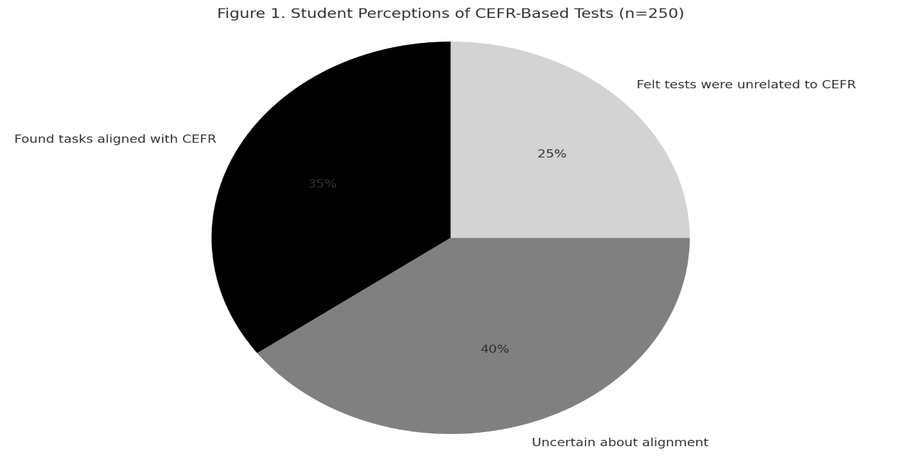

***Figure 1. Student Perceptions of CEFR-Based Tests (n = 250)*** *(Source: Student survey, April 2025)*

These results indicate a lack of transparency and student-facing communication regarding assessment goals and CEFR alignment. They also raise questions about the extent to which internal tests reflect CEFR principles in practice.

To investigate the extent of CEFR integration in institutional assessment, six internal English tests (two per university) were systematically analyzed about their structure, content, and alignment with CEFR descriptors. As shown in **Figure 2**, the findings reveal notable discrepancies in CEFR-based design practices across the three institutions:

***- Tan Trao University*** demonstrated the strongest level of alignment (**60%**), incorporating a mix of communicative and task-based items that reflected CEFR descriptors at the A2–B1 levels. Tasks such as short guided writing, listening for main ideas, and situational dialogues suggested an emerging shift toward outcome-oriented assessment.

***- Hung Vuong University*** followed with a moderate alignment score (**45%**), where some task types resembled CEFR-informed formats; however, the tests lacked explicit reference to CEFR levels or the use of standardized performance rubrics.

***- Tay Bac University***, with the lowest alignment score (**30%**), continued to emphasize traditional grammar-translation exercises, showing limited integration of communicative tasks or CEFR-relevant competencies.

These results highlight a substantial divergence in institutional interpretations of CEFR-based assessment. In the absence of common design frameworks or professional development support, the integration of CEFR remains largely ad hoc and lecturer-dependent, rather than being embedded into institutional quality assurance mechanisms.

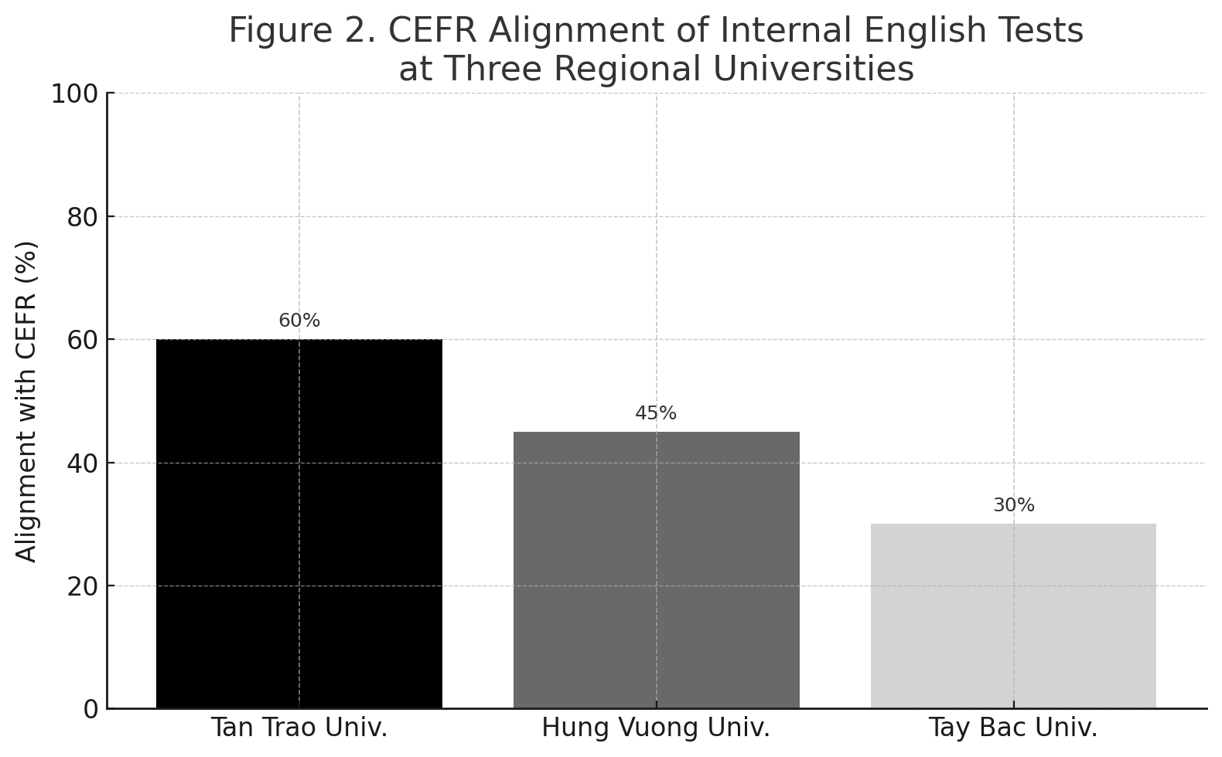

***Figure 2. CEFR Alignment of Internal English Tests at Three Regional Universities*** *(Source: Author’s analysis of institutional test samples, 2024)*

This variation underscores the absence of standardized institutional frameworks or test development guidelines grounded in CEFR. None of the examined tests fully integrated CEFR-aligned rubrics, level labels, or skill integration approaches. Moreover, test developers lacked access to item banks or design models tailored to CEFR standards, further contributing to inconsistencies across institutions.

In summary, despite policy-level encouragement, internal CEFR implementation in local universities remains ad hoc and uneven. These findings highlight the urgent need for capacity building, shared assessment resources, and a clearer institutional roadmap for CEFR-based test design at the local level.

The findings from both student surveys and internal test analysis confirm a persistent gap between CEFR policy adoption and actual assessment practice in regional Vietnamese universities. While individual efforts, particularly at Tan Trao University, indicate some degree of CEFR awareness in test construction, such practices are neither systematic nor institutionally mandated. The author contends that the current implementation of CEFR-based assessment in these institutions is more symbolic than structural, lacking the standardized frameworks and pedagogical support necessary for authentic alignment. Without coherent institutional strategies, shared resources, or sustained professional development, regional universities risk reinforcing assessment practices that remain detached from competency-based principles. This misalignment not only undermines assessment validity but also hinders students' ability to engage with CEFR as a meaningful framework for language development. These findings underscore the critical role of institutional leadership and academic capacity in operationalizing CEFR in context-sensitive ways.

*4.2. Stakeholder Perceptions and Institutional Challenges in CEFR Implementation.* Interviews with 15 English language lecturers and 6 academic managers revealed a range of perspectives on the feasibility and effectiveness of CEFR-based assessment in regional university settings. Although nearly all participants expressed general support for CEFR principles, particularly its emphasis on communicative competence and learner-centered outcomes, significant challenges emerged regarding its institutional integration.

The most prominent issues identified are summarized in **Figure 3**. A striking **81%** of respondents cited a **lack of formal training** in CEFR-based test design as a primary obstacle. Many lecturers acknowledged that while they were familiar with CEFR terminology, they lacked the pedagogical knowledge and technical tools to translate descriptors into concrete assessment items.

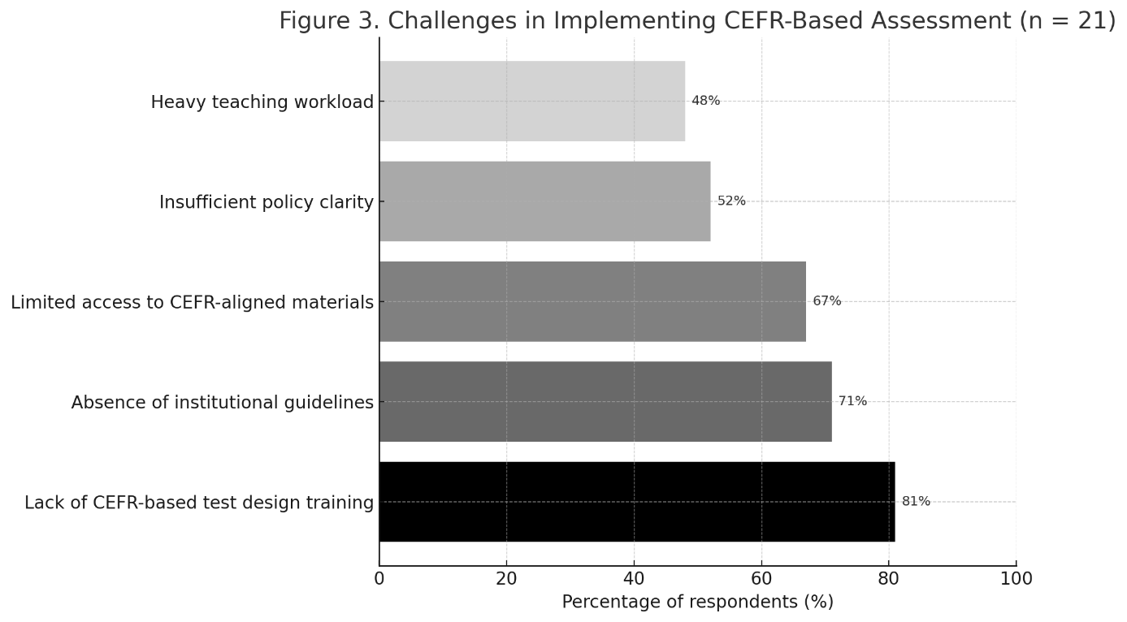

***Figure 3. Challenges in Implementing CEFR-Based Assessment (n = 21)****(Source: Interview analysis, conducted April 2025)*

In addition, **71%** of participants highlighted the **absence of institutional guidelines** for CEFR adoption, resulting in inconsistent practices across faculties. Some universities had included CEFR in policy documents or strategic plans, but these were often vague, outdated, or not operationalized at the departmental level.

Approximately **67%** pointed to a **lack of access to CEFR-aligned materials**, including test banks, model rubrics, and validated descriptors in Vietnamese. Several lecturers also mentioned their reliance on outdated or translation-based assessment tasks due to the scarcity of contextualized CEFR resources.

Beyond materials and training, over **half of the respondents (52%)** noted that **CEFR-related policies remain ambiguous** or unevenly communicated, particularly in local universities where national directives are often interpreted loosely or without support mechanisms.

Finally, **48%** of lecturers indicated that their **teaching workload** constrained their ability to redesign assessments, attend training workshops, or engage in collaborative test development.

Together, these insights underscore a clear disconnect between CEFR policy ambitions and institutional readiness. While the framework is conceptually welcomed, its practical implementation remains constrained by human, structural, and pedagogical limitations. As the findings suggest, addressing these challenges requires more than top-down mandates—it calls for institutional investment in staff development, inter-university collaboration, and context-sensitive adaptation of CEFR tools.

*4.3. Student Experiences with CEFR-Oriented Testing.* The survey results from 250 non-English-major students provide valuable insights into their experiences and perceptions of CEFR-oriented assessment practices. Despite formally introducing CEFR standards into curricula, students' learning experiences and test preparedness reflect significant challenges.

First, many students reported difficulties in adapting to competency-based test formats. Specifically, over 58% of surveyed students found communicative and task-based assessments, such as role-plays, email writing, and listening comprehension, more difficult than traditional multiple-choice grammar tests. This suggests a gap between their prior learning experiences, typically oriented around rote memorization and discrete-point grammar testing, and the new performance-based expectations aligned with CEFR.

Second, the lack of sufficient exposure to CEFR-aligned practice materials was widely acknowledged. Only 29% of students reported having regular access to CEFR-like tasks during their course preparation. Consequently, many felt unprepared to handle real-life communicative tasks under test conditions. This lack of preparation not only undermined their confidence but also contributed to negative perceptions of fairness and transparency in assessment.

Additionally, students expressed a strong desire for more practice opportunities that align with CEFR descriptors. Over 74% of respondents indicated that they would prefer more formative assessments, mock tests, and targeted feedback sessions based on CEFR performance criteria. Their comments suggested that better scaffolding, through progressive skill-building aligned with CEFR levels, could enhance their learning outcomes and assessment performance.

In summary, while students are not resistant to CEFR-oriented assessment per se, their experiences reveal a critical need for more systematic curricular support, better alignment between classroom activities and test formats, and increased transparency regarding assessment standards.

The findings from student feedback resonate strongly with broader concerns about the sustainability of CEFR-based reforms in local university contexts. The author contends that students’ difficulties are not a reflection of unwillingness or incapacity but are symptomatic of systemic gaps in curriculum design, instructional support, and assessment preparation. Without explicit scaffolding and regular exposure to CEFR-informed tasks, the benefits of competency-based assessment cannot be fully realized. Thus, any future initiatives aimed at embedding CEFR standards into local universities must prioritize not only test redesign but also learner-centered preparation strategies that bridge traditional and competency-based paradigms.

4*.4. Contributions of the Study.* This study makes several significant contributions to the emerging scholarship on CEFR-based English assessment in local Vietnamese universities, addressing critical gaps identified in previous research.

First, unlike prior studies that primarily focused on policy analysis or teacher perceptions (e.g., Dang, 2020; Nguyen & Nguyen, 2021), this research provides **an empirical examination of internal English tests** developed by regional universities. Through the systematic analysis of six institutional test papers, the study uncovers the extent and limits of CEFR alignment in locally constructed assessments, a dimension that has remained largely unexplored in the Vietnamese context.

Second, the study offers **a comparative perspective across multiple regional universities**, revealing substantial disparities in CEFR integration. By documenting differences among Tan Trao, Hung Vuong, and Tay Bac universities, the research highlights the role of institutional capacity, leadership commitment, and staff development in shaping the localization of CEFR standards.

Third, the research foregrounds **diverse stakeholder voices**, including those of students, lecturers, and academic managers. This triangulated approach provides a more nuanced and holistic understanding of the practical challenges and pedagogical implications associated with CEFR implementation in under-resourced settings—an area often overlooked in top-down policy narratives.

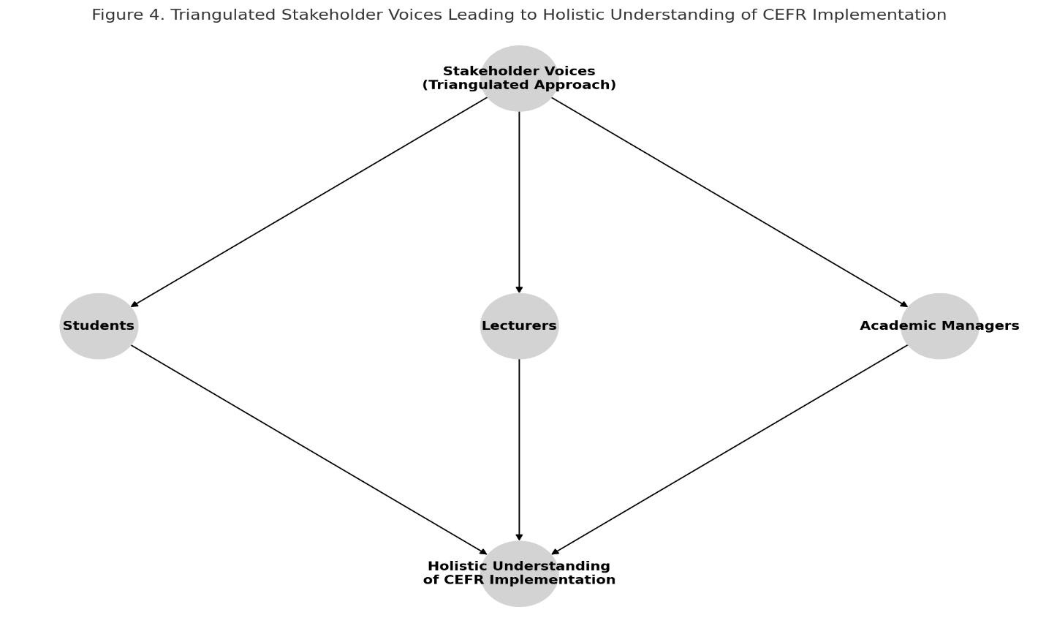

***Figure 4. Triangulated Stakeholder Voices Leading to a Holistic Understanding of CEFR Implementation***

*( Stakeholder Voices (Triangulated Approach); Students, Lecturers, and Academic Managers: Holistic Understanding of CEFR Implementation)*

***Source:*** Author's synthesis based on stakeholder analysis findings (2025)

Fourth, and most critically, the study proposes **initial parameters for an institutional CEFR internalization framework** tailored to local contexts. These include:

- Developing accessible CEFR-informed item banks,

- Establishing clear internal guidelines for CEFR-aligned test construction,

- Enhancing teacher training programs focused on CEFR-based assessment literacy,

- Building formative assessment mechanisms that gradually scaffold student competencies.

In sum, this study advances the conversation beyond policy rhetoric by offering practical, evidence-based insights into how local universities can meaningfully align English assessment practices with CEFR. It thus lays the groundwork for more sustainable, context-sensitive reforms in Vietnam’s regional higher education landscape.

**5. Conclusion and Recommendations**

This study examined how local Vietnamese universities implement CEFR-aligned English assessment practices, focusing on the design of internal tests, stakeholder perceptions, and institutional challenges. The findings revealed that while CEFR principles have been formally introduced into policy discourse, their operationalization at the local level remains fragmented and inconsistent. Internal assessments showed only partial alignment with CEFR descriptors, and both students and academic staff reported limited familiarity with competency-based assessment frameworks.

From a broader perspective, the study underscores that successful CEFR implementation cannot rely solely on top-down mandates. Instead, it requires a dynamic interplay between institutional leadership, professional capacity building, and context-sensitive resource development. Without such localized strategies, CEFR risks remaining a nominal reform disconnected from actual pedagogical practices.

***Based on the findings, the following recommendations are proposed:***

1) Develop Institutional CEFR Frameworks: Universities should establish clear internal guidelines for CEFR-aligned test design, supported by localized item banks and assessment rubrics.

2) Enhance Staff Development: Regular, practice-oriented training workshops on CEFR-based assessment literacy should be integrated into faculty development programs.

3) Strengthen Formative Assessment Practices: Greater emphasis should be placed on scaffolding students' competencies through formative assessments aligned with CEFR descriptors.

4) Foster Student Awareness and Preparedness: Institutions should actively communicate assessment standards to students and offer opportunities for practice with CEFR-oriented tasks.

5) Promote Inter-University Collaboration: Regional institutions could benefit from collaborative initiatives, such as shared resources and joint training, to strengthen collective capacity for CEFR implementation.

Ultimately, aligning internal English assessment with CEFR in local Vietnamese universities demands not only policy alignment but also sustained academic empowerment, practical innovation, and cultural adaptation to local learning environments.

**6. References**

Alderson, J. C. (2007). The CEFR and the need for more research. *The Modern Language Journal*, 91(4), 659–663. https://doi.org/10.1111/j.1540-4781.2007.00627.x

British Council. (2021). *CEFR standardisation workshops and capacity building in Vietnam*. British Council Vietnam.

Council of Europe. (2020). *Common European Framework of Reference for Languages: Learning, teaching, assessment—Companion volume*. Council of Europe Publishing. https://www.coe.int/en/web/common-european-framework-reference-languages

Dang, T. T. (2020). CEFR in Vietnamese English language education: Policy adoption and local implementation challenges. *Asian Englishes*, 22(3), 245–258. https://doi.org/10.1080/13488678.2020.1717792

Doan, M. N. (2023). Meeting B1 CEFR standards: Challenges among Vietnamese EFL students. *Asian Journal of English Language Studies*, 11(1), 23–45.

Figueras, N. (2012). The impact of the CEFR. *ELT Journal*, 66(4), 477–485. https://doi.org/10.1093/elt/ccs037

Hai, N. T., & Nhung, T. T. (2019). Teacher perceptions of CEFR-oriented English language education reform in Vietnam. *Journal of Asia TEFL*, 16(4), 1421–1438.

Le, T. H. (2020). Training teachers for CEFR-based English instruction in Vietnam: Challenges and strategies. *International Journal of English Language Teaching*, 8(2), 56–70.

Little, D. (2011). The Common European Framework of Reference for Languages: A research agenda. *Language Teaching*, 44(3), 381–393. https://doi.org/10.1017/S0261444811000095

Ministry of Education and Training (MoET). (2019). *Guidelines on CEFR-V application in foreign language education*. Hanoi: MoET Press.

Ministry of Education and Training (MoET). (2023). *National Strategy for Foreign Language Education in Vietnam, 2023–2030*. Hanoi: MoET Press.

Nguyen, T. M. T., & Nguyen, Q. H. (2021). CEFR adoption in Vietnamese tertiary education: Issues and tensions. *International Journal of Language Testing*, 11(1), 23–40.

Ngo, M. H. (2023). English proficiency, CEFR standards, and employability in Vietnam: A longitudinal study. *Asian-Pacific Journal of Second and Foreign Language Education*, 8(1), 10.

North, B., & Piccardo, E. (2016). Developing illustrative descriptors of aspects of mediation for the CEFR. *Language Teaching*, 49(3), 431–435. https://doi.org/10.1017/S0261444816000103

O’Dwyer, F., Imig, A., & Nagai, N. (2017). The European Framework of Reference for Languages: A meta-analysis of the impact in Asian contexts. *Asian EFL Journal*, 19(4), 7–35.

Pham, T. H., & Phan, H. T. (2022). CEFR-based curriculum reform and teacher capacity building: A Vietnamese perspective. *TESOL Journal*, 13(2), e00575. https://doi.org/10.1002/tesj.575

Tran, T. T. (2019). Localising CEFR in Vietnam: Policy perspectives and pedagogical realities. *Journal of Multilingual and Multicultural Development*, 40(6), 507–521.

Vo, T. T., & Doan, N. T. (2022). Integrating digital tools for CEFR-oriented English language assessment in Vietnamese universities. *CALL-EJ*, 23(1), 98–116.

**Appendices**

**Appendix A.**

**Student Questionnaire on CEFR-Based English Assessment**

**Section 1: Background Information**

* Gender: ☐ Male ☐ Female ☐ Other
* Major: _______________________
* Year of Study: ☐ 1st ☐2nd ☐ 3rd ☐ 4th
* University: ☐ Tan Trao ☐ Hung Vuong ☐ Tay Bac

**Section 2: Familiarity with CEFR**

1. Before this semester, had you heard of the CEFR?  
   ☐ Yes ☐ No
2. How familiar are you with the CEFR levels (A1-C2)?  
   ☐ Very familiar ☐ Somewhat familiar ☐ Not familiar at all

**Section 3: Perceptions of CEFR-Based Tests** 3. I understand how my English tests are aligned with CEFR standards.  
☐ Strongly Agree ☐ Agree ☐ Neutral ☐ Disagree ☐ Strongly Disagree

1. The tasks in my English tests reflect real-life communication.  
   ☐ Strongly Agree ☐ Agree ☐ Neutral ☐ Disagree ☐ Strongly Disagree
2. Which type of test do you find more challenging?  
   ☐ Traditional grammar-based ☐ Communicative/Task-based ☐ Both equally

**Section 4: Preparation and Support**

6. I was given enough CEFR-oriented practice before taking the English tests.  
 ☐ Strongly Agree ☐ Agree ☐ Neutral ☐ Disagree ☐ Strongly Disagree

1. What suggestions do you have to improve CEFR-based English tests?

…………………………………………………………………………………..

**Appendix B.**

**Semi-Structured Interview Guide for Lecturers and Academic Managers**

**Part 1: Background and Familiarity**

* Can you describe your experience with CEFR-aligned assessment?
* Have you received any formal training on CEFR-based test design?

**Part 2: Assessment Practices**

* How does your institution guide the development of CEFR-aligned English tests?
* How are CEFR descriptors integrated into current testing practices?
* What challenges have you encountered when implementing CEFR-based assessments?

**Part 3: Institutional Support and Resources**

* Are there any internal documents, rubrics, or item banks related to CEFR that you use?
* What additional support would help you implement CEFR more effectively?

**Part 4: Future Improvements**

* In your opinion, what strategies could enhance CEFR adoption in your institution?
* How can universities better prepare students for CEFR-oriented assessments?

**Appendix C.**

**CEFR Alignment Checklist for Test Document Analysis**

| **Criteria** | **Yes** | **No** | **Comments** |
| --- | --- | --- | --- |
| 1. Test tasks are communicative and real-world based | ☐ | ☐ |  |
| 2. Skills integrated (e.g., reading-writing, listening-speaking) | ☐ | ☐ |  |
| 3. CEFR level(s) explicitly stated (e.g., A2, B1) | ☐ | ☐ |  |
| 4. Performance rubrics used (aligned with CEFR) | ☐ | ☐ |  |
| 5. Task instructions align with CEFR descriptors | ☐ | ☐ |  |
| 6. Focus on competency, not just grammar knowledge | ☐ | ☐ |  |
| 7. Task types include role-plays, email writing, etc. | ☐ | ☐ |  |
| 8. Authentic texts/situations are included | ☐ | ☐ |  |